**Name:___________________**

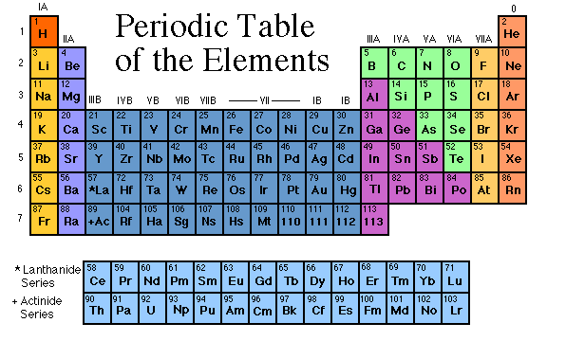**Periodic Table**

**Internet Investigation**

**Instructions: In each of the websites listed, find the information asked for.**

<https://www.chemicool.com/definition/reactivity.html>

**Define Reactivity: ______________________________________________________________________**

**_______________________________________________________________________________________**

**Element with highest reactivity: ______________________________________________________________________________________________________________________________________________________________________________**

**Element with lowest reactivity: ______________________________________________________________________________________________________________________________________________________________________________**

**“Let’s Get Organized”** Go to

<http://www.chem4kids.com/files/elem_pertable.html>

1. Why are the elements placed in specific places on the Periodic Table?
2. Periods are ___________ that run from left to right.
3. Elements in the same period have the same ________________________.
4. Every element in the first period has ________ energy level for its ____________. Every element in the second period has _____________ for its ____________. See the pattern?
5. Groups are _______________ that run from top to bottom.
6. The elements of a group have the same number of ____________ in their ___________ shell. Every element in group one has _________ electron in its outer shell. Every element in group two has ___________ electrons in its outer shell.

**“Family Fun”**

**Go to** [**http.//chemicalelements.com/**](http://www.chemicalelements.com)

1. Click on Alkali Metals (left bar) and answer the following questions.
2. What is the group number?
3. Are these metals reactive?
4. Do these metals occur freely in nature?
5. How many electrons are in their outer shell?
6. What are the three characteristics of ALL metals?
7. Are these metals soft or hard?
8. Name the two most reactive elements in this group?
9. What happens when they are exposed to water?
10. Click on Alkaline Earth Metals (left bar) and answer these questions.
11. What is the group number?
12. Are these metals reactive?
13. Do these metals occur freely in nature?
14. How many electrons are in their outer shell?
15. Click on Transition Metals (left bar) and answer these questions.
16. How many elements are in this group?
17. What are the group numbers?
18. What are valence electrons?
19. Because the valence electrons are present in more than one _____________ transition metals often exhibit several common __________________.
20. Click on Metalloids to answer these questions.
21. Metalloids are the elements found along the _________________ that distinguishes ________ from __________________.
22. Metalloids have properties of both ________ and _____________.
23. Click in Nonmetalsto answer these questions**.**
    1. What are the group numbers?
    2. List four characteristics of ALL nonmetals.
    3. What two states of matter do nonmetals exist in at room temperature?
    4. The nonmetals have no _______________and do not ________________.
24. Click on the Halogens(left bar) to answer these questions**.**
    1. What is the halogen group number?
    2. Are halogens metals or nonmetals?
    3. How many electrons are in their outer shell?
    4. What states of matter do halogens exist in at room temperature?
25. Click on Noble Gases(left bar) and answer these questions**.**
    1. What is the group number?
    2. Why were these gases considered to be inert or stable?
26. Click on Rare Earth Elements (Inner Transition)(left bar) and answer thesequestions.
    1. How many Rare Earth elements are there?
    2. The Rare Earth metals are found in group _______________and periods ______________and _______________.

**Metals, Non-metals, Metalloids**

**Go to** <http://www.mikeblaber.org/oldwine/chm1045/notes/Periodic/Metals/Period06.htm>

**Properties of Metals:**

1. Malleable (define)
2. Ductile (define)
3. Forms _________________ compounds with non-metals
4. All metals are ______________________ at room temperature except for __________ which is a liquid.
5. Good conductors of ______________ and _________________

**Properties of Non-Metals:**

1. Non-lustrous (define)
2. __________________ conductors of heat and electricity

**Properties of Metalloids:**

1. Has similar properties to both ________________ and ___________________
2. Silicon: describe the properties & use of silicon.

**Trends in Metallic Character:**

1. Describe the trend in metallic character on the periodic table.
2. What element has the most metallic character?
3. What element has the least metallic character?